|  |
| --- |
| Thinking and Learning  in  Primary Languages  Comparing the Fairy Tales  Goldilocks  Little Red Riding Hood  Three Billy Goats Gruff  Three Little Pigs  in  français Deutsch espagnol italiano |

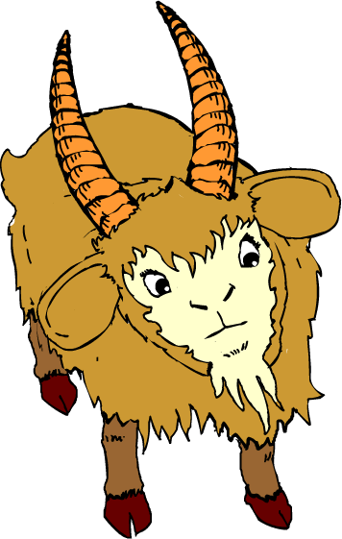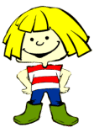

***Have you read Boucle d’Or but ever wondered what the story might sound like in one of the other languages? Then why not read Goldlöckchen, Rubiales and Ricciolidoro to find out***

If you have already been using **The Fairy Tales** in your main focus language, you will already be on your way to becoming more confident in the role of a skilled facilitator to language learning. You might now like to consider adding breadth and depth to your own and your children’s language learning experience by comparing the fairytales in different languages.

This new resource will hopefully encourage you, whether a specialist or non-specialist, to engage the same thinking skills of looking for similarities and differences, spotting patterns and making connections. The activities at text, word and sentence levels focus on building up knowledge about language and language learning strategies and will allow the children to transfer their new found skills from one language to another.

You will find that your children will start to respond personally to the languages they are exposed to and start to feel like real language learners. With their language learning experience enriched in this way, they will also be in a strong position to make an informed choice if and when they are called upon to choose a language to study at a later date.

Note

On the whole it will be assumed that the fairy tale will have been studied in depth in one language first, although it would be possible with some adjustments to study the tale with a comparative focus from the beginning.

**Contents**

|  |  |
| --- | --- |
| **Which Language? (Auditory)** | 4-5 |
| **Which Language? (Auditory Text Identification)** | 6-7 |
| **Which Language? (Visual)** | 8-15 |
| **Which Language? (Visual Text Identification)** | 16-17 |
| **Text Level**  **Three Billy Goats Gruff**  **Goldilocks**  **Little Red Riding Hood**  **The Three Little Pigs** | 18-21  22-25  26-29  30-33 |
| **Word Level**  **Three Billy Goats Gruff**  **Goldilocks**  **Little Red Riding Hood**  **The Three Little Pigs** | 34  35-38  39-42  43-46  47-50 |
| **Sentence Level**  **Three Billy Goats Gruff**  **Goldilocks**  **Little Red Riding Hood**  **The Three Little Pigs** | 51  52-53  54-55  56-57  58-59 |
| **Special Characters for Keyboards**  **Thanks to Learning and Teaching Scotland** | 60-63 |
| **National flags** | 64-65 |

|  |  |
| --- | --- |
| **Which Language? (Auditory)** | |
| Purpose | * to develop listening skills by listening for a purpose * to make deductions and comparisons * to see similarities, differences and relationships between languages * to make judgements informed by reasons and evidence * to develop language learning strategies and knowledge about language |
| Links to KS2 framework | * O3.1 Listen and respond to simple rhymes, stories and songs * O3.2 Recognise and respond to sound patterns and words * O4.2 Listen for specific words and phrases * O4.3 Listen for sounds, rhyme and rhythm * IU3.1 Increase awareness of linguistic diversity * IU4.3 Compare traditional stories * KAL Imitate pronunciation of sounds * LLS Compare the language with English (and other European Languages) |
| Preparation | You will need:   * A recording of the Three Billy Goats Gruff/Goldilocks/Little Red Riding Hood/Three Little Pigs story in French, German, Spanish and Italian (Northumberland Grid for Learning) |
| Activity | * Ask pupils to listen carefully to part of the story (perhaps the first page or two) in each of the languages. Ask them to share their thoughts on what they’ve heard after each language. They will be expressing their personal opinions just as they would if they had been listening to pieces of music so be sensitive as they feedback. Encourage them to explain their statements and give examples where possible. (You could allow them to share their thoughts with response partners prior to class discussion if you prefer) * Please bear in mind that for many of the children (and teachers!) this will be the first time they may have been exposed to some of the languages and these will be merely their initial impressions. They may change their opinions as they hear more. * You may want to consider these points in the discussion: what kind of sounds did they hear? – soft/hard, high/low pitch? did they like the sounds? did some sounds come up more frequently than others? can they imitate them? shape of mouth to make the sounds? was there a particular rhythm ie did the sounds vary by going up and down or did they stay on the same level? speed of delivery? how did it sound in comparison to English? which did they like the sound of the best? * As you move on to other languages comparisons between them should start to emerge |
| Debrief | Ask pupils what they discovered about language through the process and how they discovered it. What skills did they use? i.e. discussing, explaining, reasoning, justifying, making judgements etc. |

|  |  |
| --- | --- |
| **Language 1** | **Language 2** |
| Sounds:  Rhythm:  Opinions: | Sounds:  Rhythm:  Opinions: |
| Can you think which language this may be? | Can you think which language this may be? |
| **Language 3** | **Language 4** |
| Sounds:  Rhythm:  Opinions: | Sounds:  Rhythm:  Opinions: |
| Can you think which language this may be? | Can you think which language this may be? |
| If you had to choose the language that you liked listening to the best which one would it be?  Language 1/Language 2/Language 3/Language 4  Can you tell the other people you are working with about your choice and explain to them why you made it? | |

|  |  |
| --- | --- |
| **Which Language? (Auditory Text Identification)** | |
| Purpose | * to develop listening skills by listening for a purpose * to make deductions and comparisons * to see similarities, differences and relationships between languages * to make judgements informed by reasons and evidence * to develop language learning strategies and knowledge about language |
| Links to KS2 framework | * O3.1 Listen and respond to simple rhymes, stories and songs * O3.2 Recognise and respond to sound patterns and words * O4.2 Listen for specific words and phrases * O4.3 Listen for sounds, rhyme and rhythm * IU3.1 Increase awareness of linguistic diversity * IU4.3 Compare traditional stories * KAL Imitate pronunciation of sounds * LLS Compare the language with English (and other European Languages) |
| Preparation | You will need:   * A recording of the Three Billy Goats Gruff/Goldilocks/Little Red Riding Hood story in French, German, Spanish and Italian (Northumberland Grid for Learning) * A blank grid for each group * (Optional National flags for voting) * To recap some of the features and characteristics of each language from previous sessions |
| Activity | * Ask pupils to listen carefully to some text in each of the languages. Working in small groups they then discuss which language it might be. They should give reasons for their choice on the grid, referring to the relevant features and characteristics as outlined previously. You could ask them to vote and to share their thoughts on what they’ve heard after each language or wait until they’ve heard all 4. * If there is a difference of opinion in the group then a consensus should be arrived at by negotiation. However some of the alternative suggestions can be noted (if they have been justified!) and added to the feedback. |
| Debrief | Ask pupils what they discovered about language through the process and how they discovered it. What skills did they use? i.e. discussing, explaining, reasoning, justifying, making judgements etc. |

|  |  |  |  |
| --- | --- | --- | --- |
| **Which language can you hear?** | | | |
| **Language A** | **Language B** | **Language C** | **Language D** |
| Evidence: | Evidence: | Evidence: | Evidence: |
| Choice:  French  German  Spanish  Italian | Choice:  French  German  Spanish  Italian | Choice:  French  German  Spanish  Italian | Choice:  French  German  Spanish  Italian |

|  |  |
| --- | --- |
| **Which Language? (Visual)** | |
| Purpose | * to compare and contrast * to make deductions and comparisons * to see similarities, differences and relationships between languages * to make judgements informed by reasons and evidence * to develop language learning strategies and knowledge about language |
| Links to KS2 framework | * O3.1 Listen and respond to simple rhymes, stories and songs * O4.3 Listen for sounds, rhyme and rhythm * L3.1 Recognise some familiar words in written form * L4.2 Follow a familiar text, listening and reading at the same time * IU4.3 Compare traditional stories and look at the writing system of the language * LLS Use the context to determine some of the meaning * LLS Compare other languages with English * KAL Recognise that languages describe things differently |
| Preparation | You will need:   * The Three Billy Goats Gruff/Goldilocks/Little Red Riding Hood/Three Little Pigs interactive story in French, German, Spanish and Italian (Northumberland Grid for Learning) * Any of the grids that you feel may be useful for recording observations |
| Activity | * Ask pupils to follow some text from each story (avoiding the page selected for the identification activity), listening and reading at the same time. Leaving a page of text up on the screen ask pupils to spend some time thinking about what they have noticed about how the language looks and if they have recognised any special features. * Ask them to share their thoughts on what they’ve seen after each language and any further thoughts on what they’ve heard. Encourage them to explain their statements and give examples where possible. (You could allow them to share their thoughts with response partners prior to class discussion if you prefer) * You may want to consider these points in the discussion: are there any cognates? (with English or between the languages), did some words come up more frequently than others? can they guess what they may mean? were there any common word endings? common letter strings? how did it look in comparison to English? (include layout, dialogue, punctuation), what about capitalisation? accented letters? double letter combinations? which did they like the look of the best? * As you move on to other languages comparisons between them should start to emerge |
| Debrief | Ask pupils what they discovered about language through the process and how they discovered it. What skills did they use? i.e. observation, discussion, explanation, reasoning, justifying, making judgements etc. |

|  |  |
| --- | --- |
| **French** | **German** |
|  |  |
| **Spanish** | **Italian** |
|  |  |
| Which language do you think looks the most like English? Try to justify your choice. | |
| Which language do you think would be the easiest for you to follow? Can you say why this would be? | |

|  |
| --- |
| **French** |
|  |
| Can you think of some things that would be fairly straight-forward when learning French: |
| Can you think of anything that might be a little tricky when learning French: |

|  |
| --- |
| **German** |
|  |
| Can you think of some things that would be fairly straight-forward when learning German: |
| Can you think of anything that might be a little tricky when learning German: |

|  |
| --- |
| **Spanish** |
|  |
| Can you think of some things that would be fairly straight-forward when learning Spanish: |
| Can you think of anything that might be a little tricky when learning Spanish: |

|  |
| --- |
| **Italian** |
|  |
| Can you think of some things that would be fairly straight-forward when learning Italian: |
| Can you think of anything that might be a little tricky when learning Italian: |

|  |  |
| --- | --- |
| **French** | **German** |
|  |  |
| Can you think of some things that would be fairly straight-forward when learning French: | Can you think of some things that would be fairly straight-forward when learning German: |
| Can you think of anything that might be a little tricky when learning French: | Can you think of anything that might be a little tricky when learning German: |

|  |  |
| --- | --- |
| **Spanish** | **Italian** |
|  |  |
| Can you think of some things that would be fairly straight-forward when learning Spanish: | Can you think of some things that would be fairly straight-forward when learning Italian: |
| Can you think of anything that might be a little tricky when learning Spanish: | Can you think of anything that might be a little tricky when learning Italian: |

|  |  |
| --- | --- |
| **Which Language? (Visual Text Identification)** | |
| Purpose | * to compare and contrast * to make deductions and comparisons * to see similarities, differences and relationships between languages * to make judgements informed by reasons and evidence * to develop language learning strategies and knowledge about language |
| Links to KS2 framework | * L3.1 Recognise some familiar words in written form * L4.2 Follow a familiar text, listening and reading at the same time * IU4.3 Compare traditional stories and look at the writing system of the language * LLS Use the context to determine some of the meaning * LLS Compare other languages with English * KAL Recognise that languages describe things differently |
| Preparation | You will need:   * The relevant set of 4 text cards (Texts A B C D) in French, German, Spanish and Italian for each group to annotate * blank grid for each group to record evidence |
| Activity | * Ask pupils to read the text cards for each language and to annotate them to show any special features and characteristics that will provide clues. Make a list of evidence on blank grid and reach a decision about each text. Depending on how much time you have this could be for one language or all 4. * Take feedback and ask for evidence. * You may want to consider these points in the discussion: are there any cognates? patterns of common word endings? correct type of accents and punctuation? use of capitals? words already known? |
| Debrief | Ask pupils what they discovered about language through the process and how they discovered it. What skills did they use? i.e. observation, discussion, explanation, reasoning, justifying, making judgements etc. |

|  |  |  |  |
| --- | --- | --- | --- |
| **Which language can you identify?** | | | |
| **Text A** | **Text B** | **Text C** | **Text D** |
| Evidence: | Evidence: | Evidence: | Evidence: |
| Choice:  French  German  Spanish  Italian | Choice:  French  German  Spanish  Italian | Choice:  French  German  Spanish  Italian | Choice:  French  German  Spanish  Italian |

**Text A – Three Billy Goats Gruff**

|  |  |
| --- | --- |
|  | Un topolino è uscito da un buco inun albero."State attenti ragazzi.C’è un enorme orco cattivo che vive sotto il ponte. Fa paura.Se provate ad attraversare il ponte, vi mangerà." |

**Text B - Three Billy Goats Gruff**

|  |  |
| --- | --- |
|  | Eine kleine Maus tauchte aus einem Loch im Baum auf, wo sie wohnte. „Aber passt doch gut auf!˝ sagte sie zu den Ziegenböcken. „Ein großer böser Troll wohnt unter der Brücke und er hat einen großen Hunger. Wenn ihr versucht, über die Brücke zu gehen, wird er euch ertappen und auffressen.˝ |

**Text C - Three Billy Goats Gruff**

|  |  |
| --- | --- |
|  | De repente, un ratón se asomó por el agujero de un árbol.  “Tened cuidado,” le dijo a los cabritillos. “Un ogro grande y feo vive debajo del puente.¡Si intentáis cruzar, os cogerá y os comerá!” |

**Text D - Three Billy Goats Gruff**

|  |  |
| --- | --- |
|  | Une gentille petite souris a sorti sa petite tête du trou dans l’arbre où elle habitait.«Faites attention les gars!Un troll habite sous le pont.Il est énorme et affreux, et il a un appétit féroce.Si vous tentez de traverser le pont, il vous attrapera et vous mangera.» |

**Text A - Goldilocks**

|  |  |
| --- | --- |
|  | Fueron a la sala.  “Alguien ha tocado mi silla,” gritó papá oso.  “Alguien ha tocado mi silla,” gritó mamá oso.  “Alguien ha tocado mi silla,” gritó bebé oso, “¡y la ha roto!” |

**Text B - Goldilocks**

|  |  |
| --- | --- |
|  | Ils sont allés dans le salon.  «Quelqu’un a touché ma chaise,» a crié papa ours.  «Quelqu’un a touché ma chaise,» a crié maman ours.  «Quelqu’un a touché ma chaise,» a crié bébé ours, «et l’a cassée!» |

**Text C - Goldilocks**

|  |  |
| --- | --- |
|  | Sie gingen ins Wohnzimmer.  ,,Jemand hat meinen Stuhl berührt,” rief Papa Bär.  ,,Jemand hat meinen Stuhl berührt,” rief Mama Bär.  ,,Jemand hat meinen Stuhl berührt,” rief Baby Bär, ,,und hat ihn zerbrochen.” |

**Text D - Goldilocks**

|  |  |
| --- | --- |
|  | Sono entrati nel salone. “Qualcuno ha toccato la mia sedia,” ha gridato babbo orso.“Qualcuno ha toccato la mia sedia,” ha gridato mamma orsa.“Qualcuno ha toccato la mia sedia,” ha gridato l’orsetto piccolo, “e l’ha rotta!” |

**Text A – Little Red Riding Hood**

|  |  |
| --- | --- |
|  | Kurz nachdem sie losfuhr, hatte Rotkäppchen leider eine Reifenpanne und musste das Rad schieben. Plötzlich kam ein großer Wolf.  ,,Guten Tag mein liebes Mädchen. Wohin fährst du so früh an diesem schönen Morgen?”  ,,Ich bringe Kuchen zu meiner Großmutter.” |

**Text B - Little Red Riding Hood**

|  |  |
| --- | --- |
|  | Desafortunadamente, en el camino, a la bici se le pinchó una rueda y Caperucita Roja tuvo que caminar. De repente apareció un lobo grande.  “Hola pequeña,” dijo el lobo.“¿A dónde vas en este día?”“Voy a llevar unos pasteles a mi abuela, que vive al otro lado del bosque,” dijo Caperucita Roja. |

**Text C - Little Red Riding Hood**

|  |  |
| --- | --- |
|  | Sfortunatamenta la gomma della bicicletta si buca e Cappuccetto Rosso deve andare a piedi. Improvvisamente un grande lupo le si avvicina.“Ciao bimba. Dove vai?”  “Porto dei dolci alla nonna che abita dall’ altra parte del bosco,” risponde Cappuccetto Rosso. |

**Text D - Little Red Riding Hood**

|  |  |
| --- | --- |
|  | Malheureusement en route le vélo a eu un pneu crevé. Petit Chaperon Rouge devait marcher. Tout d’un coup un grand loup s’est approché.  «Bonjour petite fille.Où vas-tu ce beau jour?»«J’apporte des gâteaux à ma grand’mère. Elle habite de l’autre côté de la forêt,» a répondu Petit Chaperon Rouge. |

**Text A – The Three Little Pigs**

|  |  |
| --- | --- |
|  | Le grand Méchant Loup est descendu par la cheminée puis il est tombé dans la marmite.  « Sors de là vite, vite, c’est un ragoût végétarien. Tu peux en avoir si tu veux. »  Le grand Méchant Loup a adoré le ragoût.  « C’est meilleur que le cochon ! » |

**Text B - The Three Little Pigs**

|  |  |
| --- | --- |
|  | Il lupo è sceso dal camino nella pentola.  “Fuori di qui. Presto! Presto! Sto cucinando uno stufato vegetariano,” ha detto Porcellino Sciocchino.  “Ne puoi avere un pò se vuoi.”  Al Lupo Cattivo lo stufato è piaciuto molto.  “È più buono dei porcellini,” ha detto. |

**Text C - The Three Little Pigs**

|  |  |
| --- | --- |
|  | Der Wolf rutschte den Schornstein herunter und landete im großen Topf.  „Schnell! Heraus da! Die Suppe soll vegetarisch sein!” schrie Schweinchen Doof.  „Wenn du willst, kannst du sie probieren.”  Der große böse Wolf mochte die Suppe.  Das schmeckte leckerer als kleine Schweinchen. |

**Text D - The Three Little Pigs**

|  |  |
| --- | --- |
|  | El lobo se cayó de la chimenea en la gran olla.  "¡Sal de allí! ¡Rápido! ¡Rápido! ¡Estoy haciendo un guiso vegetariano!", gritó Cerdito Tonto.  "Te puedo dar un poco si lo deseas".  Al Malvado Lobo le encantó el guiso."Es mejor que el guiso de cerdo". |

|  |  |
| --- | --- |
| Word Level | |
| Purpose | * to make deductions * to make judgements informed by reasons and evidence * to develop language learning strategies and knowledge about language |
| Links to KS2 framework | * O3.2 Recognise and respond to sound patterns and words * L3.1 Recognise some familiar words in written form * O4.2 Listen for specific words and phrases * O4.3 Listen for sounds, rhyme and rhythm * L4.3 Read some familiar words and phrases aloud and pronounce them accurately |
| Preparation | Pupils work in groups of 3 or 4. Each group will need:   * set of word cards pre-cut (Set A or Set B) for the appropriate story (NB the words appear in the same order of language in the uncut version to provide the teacher with the correct answers)   OR   * 1 sheet Word Level (A)/Word Level (B) for the appropriate story * coloured pencils |
| Activity | * Recap common features of each language as identified in previous sessions * Ask pupils to sort their cards according to meaning ie the same word in all the languages * Ask them to explain their choices. Right or wrong, the reasons they give are very important as they are articulating language learning strategies. * Ask them to comment on the spelling of the words and on any similarities between the languages * See if they can now sort all the words of the same language together * Once this activity has been completed, the Word Level sheets could be used. Ask pupils to look at each word and colour code them according to language (French = blue, German = red, Spanish = yellow, Italian = green) |
| Debrief | Ask pupils what they discovered about language through the process and how they discovered it. What skills did they use? i.e. discussing, explaining, reasoning, justifying, making judgements etc. |

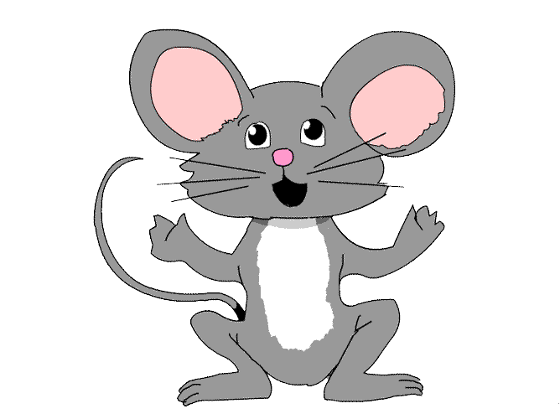

**Los Tres Cabritillos Traviesos**

**Les Trois Boucs Bourrus / Three Billy Goats Gruff**

**I Tre Capretti Furbetti / Die drei Ziegenböcke**

Word Level (A)

Show which language you think each word is by highlighting them with these colours:

German=red Spanish=yellow French=blue Italian=green

|  |  |  |  |
| --- | --- | --- | --- |
| un topolino  a mouse  eine Maus  une souris  un ratón | herbe  Gras  hierba  grass  erba | the bridge  el puente  il ponte  die Brücke  le pont | mi hermano  mon frère  my brother  mio fratello  mein Bruder |

**Los Tres Cabritillos Traviesos**

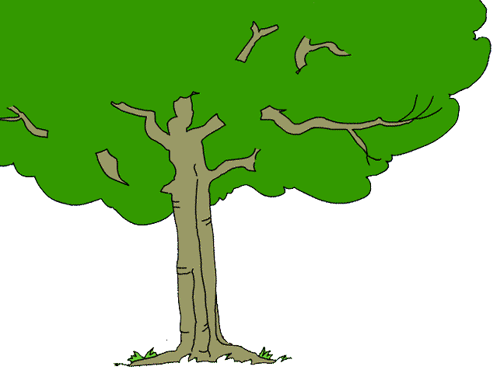

**Les Trois Boucs Bourrus / Three Billy Goats Gruff**

**I Tre Capretti Furbetti / Die drei Ziegenböcke**

Word Level (B)

Show which language you think each word is by highlighting them with these colours:

German=red Spanish=yellow French=blue Italian=green

|  |  |  |  |
| --- | --- | --- | --- |
| un albero  a tree  ein Baum  un arbre  un árbol | la rivière  der Fluss  el río  the river  il fiume | Billy Goats  Cabritillos  Capretti  Ziegenböcke  Boucs | un valle  une vallée  a valley  una valle  ein Tal |

|  |  |  |  |
| --- | --- | --- | --- |
| **un topolino** | **erba** | **il ponte** | **mio fratello** |
| **a mouse** | **grass** | **the bridge** | **my brother** |
| **eine Maus** | **Gras** | **die Brücke** | **mein Bruder** |
| **une souris** | **herbe** | **le pont** | **mon frère** |
| **un ratón** | **hierba** | **el puente** | **mi hermano** |

|  |  |  |  |
| --- | --- | --- | --- |
| **un albero** | **il fiume** | **Capretti** | **una valle** |
| **a tree** | **the river** | **Billy goats** | **a valley** |
| **ein Baum** | **der Fluss** | **Ziegenböcke** | **ein Tal** |
| **un arbre** | **la rivière** | **Boucs** | **une vallée** |
| **un árbol** | **el río** | **Cabritillos** | **un valle** |

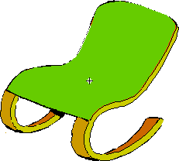

**Rubiales**

**Boucle d’Or / Goldilocks**

**Ricciolidoro / Goldlöckchen**

Word Level (A)

Show which language you think each word is by highlighting them with these colours:

German=red Spanish=yellow French=blue Italian=green

|  |  |  |  |
| --- | --- | --- | --- |
| tre orsi  three bears  drei Bären  trois ours  tres osos | Boucle d’Or  Goldlöckchen  Rubiales  Goldilocks  Ricciolidoro | the chair  la silla  la sedia  der Stuhl  la chaise | una carta  une lettre  a letter  una lettera  ein Brief |

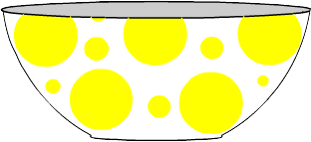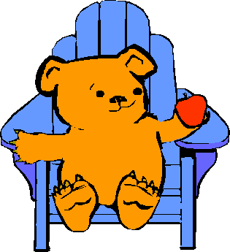

**Rubiales**

**Boucle d’Or / Goldilocks**

**Ricciolidoro / Goldlöckchen**

Word Level (B)

Show which language you think each word is by highlighting them with these colours:

German=red Spanish=yellow French=blue Italian=green

|  |  |  |  |
| --- | --- | --- | --- |
| babbo orso  baby bear  Baby Bär  bébé ours  bebé oso | table  Tisch  mesa  table  tavola | the bed  la cama  il letto  das Bett  le lit | tres tazones  trois bols  three bowls  tre tazze  drei Schüsseln |

|  |  |  |  |
| --- | --- | --- | --- |
| **tre orsi** | **Ricciolidoro** | **la sedia** | **una lettera** |
| **three bears** | **Goldilocks** | **the chair** | **a letter** |
| **drei Bären** | **Goldlöckchen** | **der Stuhl** | **ein Brief** |
| **trois ours** | **Boucle d’Or** | **la chaise** | **une lettre** |
| **tres osos** | **Rubiales** | **la silla** | **una carta** |

|  |  |  |  |
| --- | --- | --- | --- |
| **babbo orso** | **tavola** | **il letto** | **tre tazze** |
| **baby bear** | **table** | **the bed** | **three bowls** |
| **Baby Bär** | **Tisch** | **das Bett** | **drei Schüsseln** |
| **bébé ours** | **table** | **le lit** | **trois bols** |
| **bebé oso** | **mesa** | **la cama** | **tres tazones** |

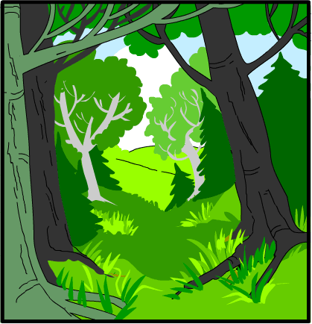

**Petit Chaperon Rouge / Little Red Riding Hood**

**Cappuccetto Rosso / Rotkäppchen / Caperucita Roja**

Word Level (A)

Show which language you think each word is by highlighting them with these colours:

German=red Spanish=yellow French=blue Italian=green

|  |  |  |  |
| --- | --- | --- | --- |
| il dente  the teeth  die Zähne  les dents  el diente | forêt  Wald  bosque  forest  bosco | Help  Aiuto  Socorro  Hilfe  Au secours | una vez  Il était une fois  Once upon a time  C’era una volta  Es war einmal |

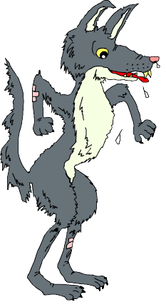

**Petit Chaperon Rouge / Little Red Riding Hood**

**Cappuccetto Rosso / Rotkäppchen / Caperucita Roja**

**Word Level (B)**

Show which language you think each word is by highlighting them with these colours:

German=red Spanish=yellow French=blue Italian=green

|  |  |  |  |
| --- | --- | --- | --- |
| il lupo  the wolf  der Wolf  le loup  el lobo | la porte  die Tür  la puerta  the door  la porta | ears  orecchi  orejas  Ohren  oreilles | ojos  yeux  eyes  occhi  Augen |

|  |  |  |  |
| --- | --- | --- | --- |
| **il dente** | **bosco** | **Aiuto** | **C’era una volta** |
| **the teeth** | **forest** | **Help** | **Once upon a time** |
| **die Zähne** | **Wald** | **Hilfe** | **Es war einmal** |
| **les dents** | **forêt** | **Au secours** | **Il était une fois** |
| **el diente** | **bosque** | **Socorro** | **una vez** |

|  |  |  |  |
| --- | --- | --- | --- |
| **il lupo** | **la porta** | **orecchi** | **occhi** |
| **the wolf** | **the door** | **ears** | **eyes** |
| **der Wolf** | **die Tür** | **Ohren** | **Augen** |
| **le loup** | **la porte** | **oreilles** | **yeux** |
| **el lobo** | **la puerta** | **orejas** | **ojos** |

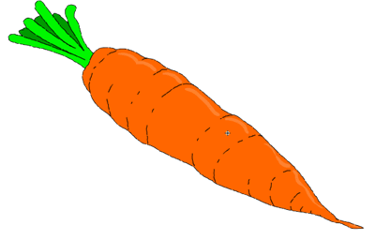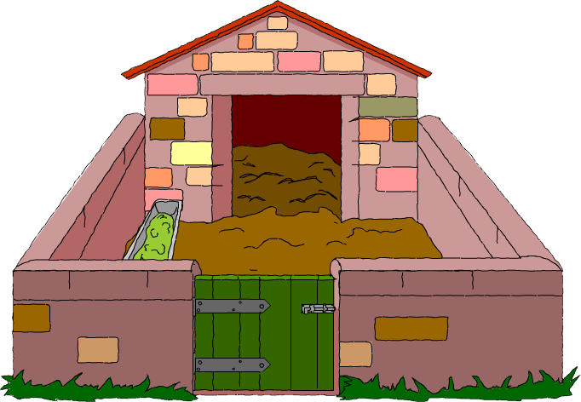

**Die drei kleinen Schweinchen / The Three Little Pigs**

**Les trois petits Cochons / I tre Porcellini / Los Tres Cerditos**

Word Level (A)

Show which language you think each word is by highlighting them with these colours:

German=red Spanish=yellow French=blue Italian=green

|  |  |  |  |
| --- | --- | --- | --- |
| un porcile  a pigsty  ein Schweinestall  une porcherie  una pocilga | délicieux  lecker  delicioso  delicious  delizioso | of straw  di paglia  de paja  aus Stroh  en paille | tres zanahorias  trois carottes  three carrots  tre carote  drei Karotten |

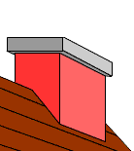

**Die drei kleinen Schweinchen / The Three Little Pigs**

**Les trois petits Cochons / I tre Porcellini / Los Tres Cerditos**

**Word Level (B)**

Show which language you think each word is by highlighting them with these colours:

German=red Spanish=yellow French=blue Italian=green

|  |  |  |  |
| --- | --- | --- | --- |
| costruire  to build  bauen  construire  construir | à la campagne  auf dem Lande  en el campo  in the countryside  in campagna | practical  pratico  práctico  praktisch  pratique | la chimenea  la cheminée  the chimney  il camino  der Schornstein |

|  |  |  |  |
| --- | --- | --- | --- |
| **un porcile** | **delizioso** | **di paglia** | **tre carote** |
| **a pigsty** | **delicious** | **of straw** | **three carrots** |
| **ein Schweinestall** | **lecker** | **aus Stroh** | **drei Karotten** |
| **une porcherie** | **délicieux** | **en paille** | **trois carottes** |
| **una pocilga** | **delicioso** | **de paja** | **tres zanahorias** |

|  |  |  |  |
| --- | --- | --- | --- |
| **costruire** | **in campagna** | **pratico** | **il camino** |
| **to build** | **in the countryside** | **practical** | **the chimney** |
| **bauen** | **auf dem Lande** | **praktisch** | **der Schornstein** |
| **construire** | **à la campagne** | **pratique** | **la cheminée** |
| **construir** | **en el campo** | **práctico** | **la chimenea** |

|  |  |
| --- | --- |
| Sentence Level | |
| Purpose | * to make deductions * to make judgements informed by reasons and evidence * to develop language learning strategies and knowledge about language |
| Links to KS2 framework | * O3.2 Recognise and respond to sound patterns and words * L3.1 Recognise some familiar words in written form * O4.2 Listen for specific words and phrases * O4.3 Listen for sounds, rhyme and rhythm * L4.3 Read some familiar words and phrases aloud and pronounce them accurately |
| Preparation | Pupils work in pairs or small groups. Each group will need:   * 1 Sentence Level (A) or (B) sheet in the appropriate story for highlighting * coloured pencils |
| Activity | * Recap common features of each language as identified in previous sessions * Ask pupils to look at each sentence and colour code it according to language (French = blue, German = red, Spanish = yellow, Italian = green) * Ask them to explain their choice. Right or wrong, the reasons they give are very important as they are articulating language learning strategies. * Ask them to comment on any similarities between the languages * Can they identify the words specified in each language? * Ask them if they think that some languages deal with some things differently ie Italian and Spanish don’t always need a subject pronoun therefore there isn’t necessarily a word for ‘he’ or ‘she’.   NB The sentences are not always an identical match but provide an opportunity to see how each language deals with different expressions. |
| Debrief | Ask pupils what they discovered about language through the process and how they discovered it. What skills did they use? i.e. discussing, explaining, reasoning, justifying, making judgements etc. |

**Los Tres Cabritillos Traviesos**

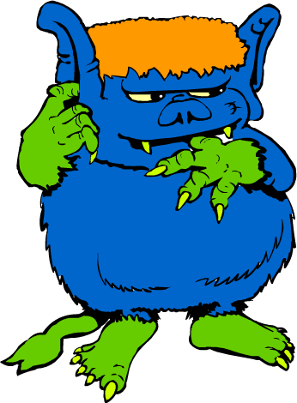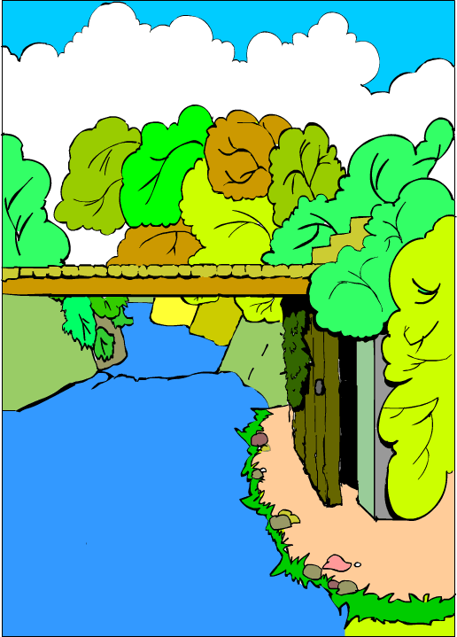

**Les Trois Boucs Bourrus / Three Billy Goats Gruff**

**I Tre Capretti Furbetti / Die drei Ziegenböcke**

**Sentence Level (A)**

Show which language you think each sentence is by highlighting them with these colours:

German=red Spanish=yellow French=blue Italian=green

|  |  |  |
| --- | --- | --- |
| 1 | * Plötzlich öffnete sich eine Tür unter der Brücke, und ein großer böser Troll sprang auf. |  |
| 2 | * Debajo del puente se abrió una puerta y de ella salió un ogro grande y feo. |  |
| 3 | * A door under the bridge opened and out popped an enormous, wicked troll. |  |
| 4 | * Una porta sotto il ponte si è aperta e dalla porta è uscito un enorme orco. |  |
| 5 | * Une porte s’est ouverte sous le pont et un énorme et affreux troll en est sorti. |  |

**under : a door : opened :**

**Los Tres Cabritillos Traviesos**

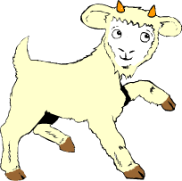

**Les Trois Boucs Bourrus / Three Billy Goats Gruff**

**I Tre Capretti Furbetti / Die drei Ziegenböcke**

**Sentence Level (B)**

Show which language you think each sentence is by highlighting them with these colours:

German=red Spanish=yellow French=blue Italian=green

|  |  |  |
| --- | --- | --- |
| 1 | * Fra poco arriva mio fratello e lui è più grande di me. |  |
| 2 | * My brother is coming soon and he is much bigger than I am. |  |
| 3 | * Mein Bruder kommt gleich und er ist viel größer als ich. |  |
| 4 | * Mon frère arrive bientôt et il est bien plus grand que moi. |  |
| 5 | * Mi hermano viene pronto y es mucho más grande que yo. |  |

**soon : he : bigger :**

**Rubiales**

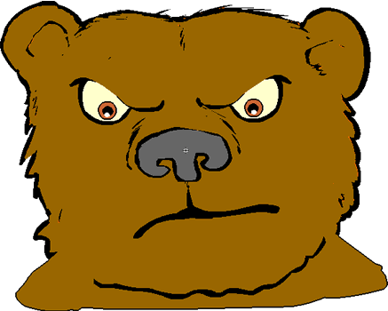

**Boucle d’Or / Goldilocks**

**Ricciolidoro / Goldlöckchen**

**Sentence Level (A)**

Show which language you think each sentence is by highlighting them with these colours:

German=red Spanish=yellow French=blue Italian=green

|  |  |  |
| --- | --- | --- |
| 1 | * Sie sah die verärgerten Bären und sie hatte Angst. |  |
| 2 | * Vio a los tres osos enfadados y estaba asustado. |  |
| 3 | * She saw the three angry bears and was frightened . |  |
| 4 | * Ha guardato i tre orsi arrabbiati e aveva paura. |  |
| 5 | * Elle a regardé les trois ours fâchés et elle avait peur. |  |

**angry : she : frightened:**

**Rubiales**

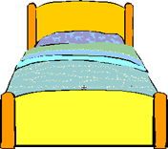

**Boucle d’Or / Goldilocks**

**Ricciolidoro / Goldlöckchen**

**Sentence Level (B)**

Show which language you think each sentence is by highlighting them with these colours:

German=red Spanish=yellow French=blue Italian=green

|  |  |  |
| --- | --- | --- |
| 1 | * Il letto medio era troppo molle. |  |
| 2 | * The medium-sized bed was too soft. |  |
| 3 | * Das mittlere Bett war zu weich. |  |
| 4 | * Le moyen lit était trop mou. |  |
| 5 | * La cama media era muy suave. |  |

**soft : too : medium :**

**Petit Chaperon Rouge / Little Red Riding Hood**

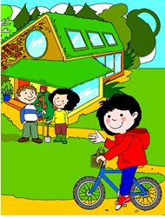

**Cappuccetto Rosso / Rotkäppchen / Caperucita Roja**

**Sentence Level (A)**

Show which language you think each sentence is by highlighting them with these colours:

German=red Spanish=yellow French=blue Italian=green

|  |  |  |
| --- | --- | --- |
| 1 | * Abitava in una bella casetta vicino a un grande bosco. |  |
| 2 | * She lived with her parents in a beautiful house on the edge of a big forest. |  |
| 3 | * Sie wohnte mit ihren Eltern in einem schönen Häuschen am Rande eines groβen Waldes. |  |
| 4 | * Elle habitait avec ses parents dans une jolie petite maison au bord d’une grande forêt. |  |
| 5 | * Vivía con sus padres en una casa bonita al borde de un gran bosque. |  |

**with : she : house :**

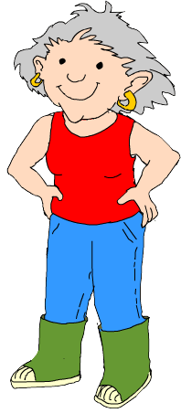

**Petit Chaperon Rouge / Little Red Riding Hood**

**Cappuccetto Rosso / Rotkäppchen / Caperucita Roja**

**Sentence Level (B)**

Show which language you think each sentence is by highlighting them with these colours:

German=red Spanish=yellow French=blue Italian=green

|  |  |  |
| --- | --- | --- |
| 1 | * Decidió correr lo más rápido posible a casa de la abuela. |  |
| 2 | * Er beschloss, so schnell wie möglich durch den Wald zum Haus der Großmutter zu laufen. |  |
| 3 | * He decided to run as fast as possible to Grandma’s house. |  |
| 4 | * Cosí decide di andare di corsa verso la casa della nonna. |  |
| 5 | * Il a décidé de courir aussi vite que possible vers la maison de la grand’mère. |  |

**grandma : possible : he decided :**

**Die drei kleinen Schweinchen / The Three Little Pigs**

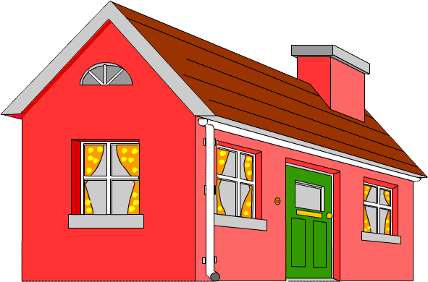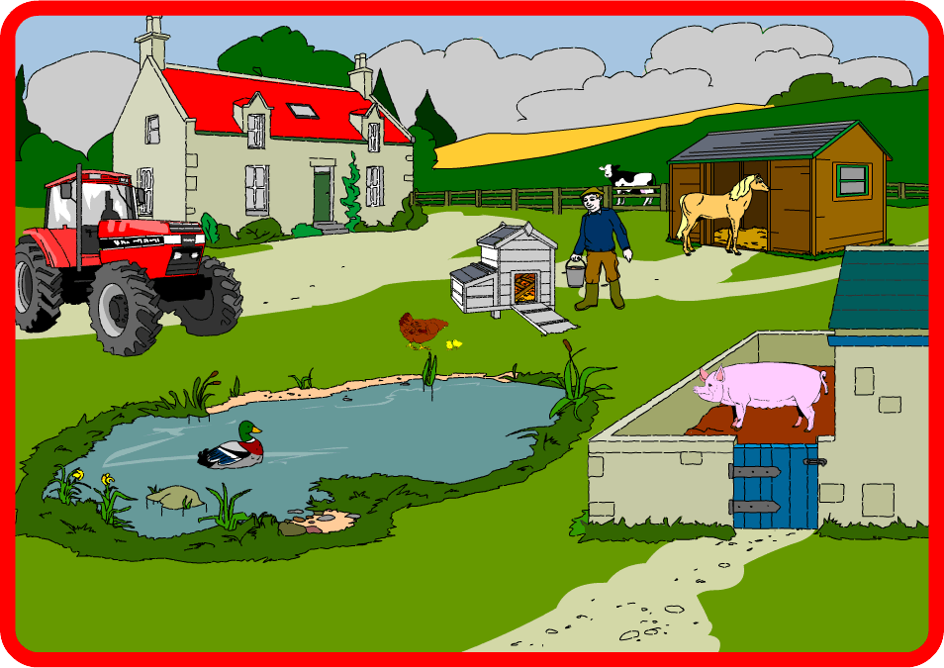

**Les trois petits Cochons / I tre Porcellini / Los Tres Cerditos**

**Sentence Level (A)**

Show which language you think each sentence is by highlighting them with these colours:

German=red Spanish=yellow French=blue Italian=green

|  |  |  |
| --- | --- | --- |
| 1 | * Una mañana muy temprano, dejaron su granja y fueron a construir sus propias lindas casitas. |  |
| 2 | * Un matin, de bonne heure, ils ont quitté la ferme bio pour construire chacun une maison. |  |
| 3 | * Una mattina, di buon’ora, hanno lasciato la fattoria biologica per costruirsi ognuno una casetta. |  |
| 4 | * Early one morning they left the farm so each one of them could build their own little house. |  |
| 5 | * Früh an einem Morgen verließen sie den Biobauernhof, weil jedes Schweinchen sein eigenes schönes Haus bauen wollte. |  |

**morning : farm : to build :**

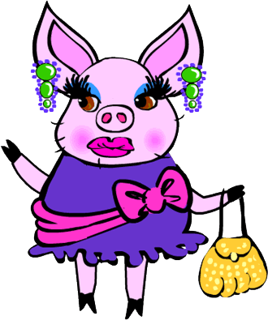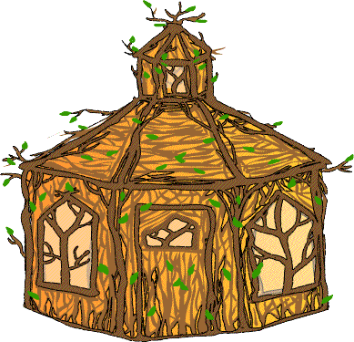

**Die drei kleinen Schweinchen / The Three Little Pigs**

**Les trois petits Cochons / I tre Porcellini / Los Tres Cerditos**

**Sentence Level (B)**

Show which language you think each sentence is by highlighting them with these colours:

German=red Spanish=yellow French=blue Italian=green

|  |  |  |
| --- | --- | --- |
| 1 | * Entonces Cerdita Glamorosa construyó una elegante casita de madera. |  |
| 2 | * Schweinchen Schick ließ sich ein elegantes Haus aus Holz bauen. |  |
| 3 | * So the glamorous pig built an elegant house out of wood. |  |
| 4 | * Dunque Porcellina Civetta ha fatto costruire una elegante casa di legno. |  |
| 5 | * Donc, Cochonnette Coquette a fait construire une élégante maison en bois. |  |

**pig : wooden : house:**





|  |  |
| --- | --- |
|  |  |

|  |  |
| --- | --- |
|  |  |